**CMSC 203**

**Fernando Gonzales-Vigil Richter**

**Assignment 1**

**Pseudocode**

DISPLAY "Wind Chill Calculator"

DISPLAY "Please enter the temperature in Fahrenheit (must be >= -45 and <= 40): "

READ temperature

DISPLAY "Please enter the wind speed (must be >= 5 and <= 60): "

READ wind

COMPUTE windchill as 35.74 + (0.6215 * temperature) + (35.75 * (wind^0.16)) + (10.4275 * temperature * (wind^0.16))

DISPLAY windchill

DISPLAY "Programmer: Fernando Gonzales-Vigil"



**Test Table**

|  |  |  |  |
| --- | --- | --- | --- |
| **Test No.** | **Temperature** | **Wind Speed** | **Wind Chill** |
| **1** | **30** | **20** | 17.361783756466327 |
| **2** | **-45** | **5** | -63.36509452295255 |
| **3** | **40** | **60** | 24.692676351298985 |
| **4** | **0** | **50** | -31.11151393303151 |

**Learning Experience**

As a programming experience, I’d say that most of the assignment was something I’ve already done, considering I already coursed CSMC 140 (same but in C++) and CSMC 141 (Java).

Regarding the IDE and Java, I’ve used text editors like Sublime Text and IDEs like NetBeans, Eclipse and IntelliJ. Returning to Eclipse meant configuring some preferences that seem to be a bit broken like autocompletion. I guess I’ll get used to it by the end of the semester

As theory, I’ve learned the difference between temperature and wind chill, which I understand is what mean the “Feels like” in most temperature sites, apps and TV channels.

**Console Screenshot**

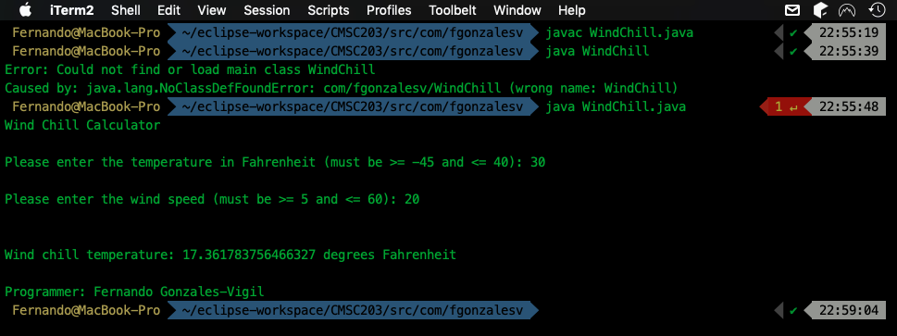

Since Java 11, there’s no need to compile with javac and then run the class file with java:

<https://openjdk.java.net/jeps/330>

Apparently, it doesn’t work anymore. I included a new console screenshot that works without a compiled file:

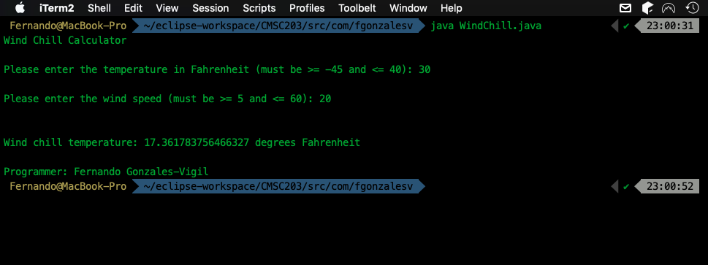

**Eclipse Screenshot**

